Période | S1 | S2 | S3 | S4 | S5 | S6 | S7 | S8
1 | X | Rappel GS, a,e,i/y | o/au/eau,u | l, r | f/ph | ou | ch | X
2 | oi, s/ss | p, d | v,j | b,n | on, om | en/an, em/am | ai, o/au/eau | X
3 | é,è,ê | s/ss/sc/c/ç | eu/oeu | è/ê/ai/ei/et | c/k/qu/q | X | X | X
4 | p/q/b/d | lettre g | j/g/ge | g/gu | z/s | in/im/ain/aim/ein | é/er/ez/es | X
5 | bl/cl/flec/el/er/es | e devant consonne double | i/y/il/ill | x | t-> s
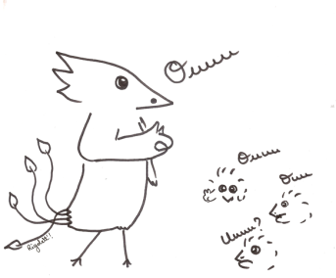
Programmation Français
CP

Phonologie

